📘 Skills for a Changing Word: entrepreneurship and Professional Studies
Frequently Asked Questions
1. What is this course about?
Skills for a Changing World has been co-designed with the voices of local residents, community advocates and industry/employer partners. The course provides an introduction to skills and knowledge in entrepreneurship and professional studies. Entrepreneurship refers to developing the skills to spot opportunities and add value. You will explore both theory and practical applications to build confidence and competence over 3 units.
2. Who is this course for?
This course is designed for beginners or those looking to develop their existing knowledge. No prior experience or qualifications are needed. The course is free and will not affect student finance if you later decide to apply for university.
3. I never thought I would go to university / I didn’t enjoy school / I don’t have A-Levels... is this course really for me?
Yes! We have designed this course specifically to support people who have life or work experience, ideas, ambitions, and potential to succeed in academic study – but who may not have thought university would be for them in the past. That’s why no prior qualifications are required on entry and why we assess your potential to success rather than your past achievements at admission.

4. I have other commitments (work, volunteering, family or a mix of these) - will I be able to fit the course in?
Everyone on the course will be juggling their studies with other commitments and we hope you will find it has been designed with you in mind. The course is designed to be flexible around whatever else is going on in your life, which is why it is usually taught in one time slot per week (Mondays 9.30am to 12.30pm) plus one Saturday morning (because of a Monday bank holiday). You will be asked to do some independent study every week. The micro-campus will be available at set times, if you will need a space to study in (see course outline for detail).

5. What will I learn?
The course aims to help you think about your own future in the context of a range of ideas about our shared futures – in Hartcliffe, in Bristol, and globally. You will learn a range of ideas relevant to tackling real-world challenges individually and by working with others, as well as skills in communication and presentation, research, and much more! By the end of the course, you will:
- Have an understand of the knowledge and skills needed for a changing world
- Apply knowledge to real-world situations
- Develop practical skills relevant to the entrepreneurship and professional studies
6. How is the course delivered?
The course will mainly be taught in one 3-hour session every week, in a group of up to 15 students. Each session will be structured in a different way and may include short lectures or presentations and group discussions or activities.
The units are sequenced with a range of activities to engage students with enquiry-led learning and place-based challenges. Support will be embedded throughout, and following the course students may go onto college, university or employment. This may include starting or scaling up your own business
7. How long does the course take?
The course runs from April to October, with breaks for half-term and the summer, aligning with the school holidays. It requires 3 hours a week of taught input on a Monday morning (9:30-12:30) and the equivalent of 3 hours in independent study per week. See course outline for dates and times.
8. Who is teaching on the course?
The course lead is Michelle Graffagnino who is a Senior Lecturer at the University of Bristol and the Hartcliffe and Withywood Micro-Qualification Lead. In addition to Michelle, the course will be delivered by Jane Hewer (Learner Engagement for Hartcliffe and Withywood Ventures), with contributions from university and industry experts. The teaching team reflects the university, community, and employer experience that underpins the course.

9. What qualifications do I need to be able to apply for the course?
Admission to the course will be on the basis of potential to succeed and not on prior achievement. You do not need any prior qualifications to apply.
🧑‍🏫 Learning & Assessment
10. How will I be assessed?
Assessment methods will include:
- Independent and group projects
- Writing for different audiences
- Practical tasks or presentations
11. Will I receive feedback?
Yes, regular feedback will be provided to help you improve and track your progress.
12. Is there a final exam?
No! There are no exams on the course.
💻 Practical Information
13. What do I need to take part?
All you need to bring with you on Day 1 is a pen and paper, any questions you have, and enthusiasm!
14. What if I am too nervous to attend the course?
The course will be a new venture for everyone involved – including the tutors, as it is a brand new course! We hope this will make it a shared adventure. We know that, as with any new step, there may be times when it feels daunting – especially to begin with. Many students reports that the hardest thing they do during a course is turn up on the first day. The course team will be happy to talk through any challenges you are facing, or any nerves you are feeling and may be able to offer a pre-visit to the micro-campus.

15. Where and what is the micro-campus?
The micro-campus is a small space the University has rented at the Gatehouse Centre, which is run by Hartcliffe and Withywood Ventures (HWV). The micro-campus opened in 2025, and the University has a similar centre at the Wellspring Settlement in Barton Hill, which opened in 2020. Both micro-campuses are spaces for a full range of university activities that are developed with the local community and partners. In 2025, the University and HWV jointly received funding from the Office for Students to develop the micro-qualification in Hartcliffe and Withywood.
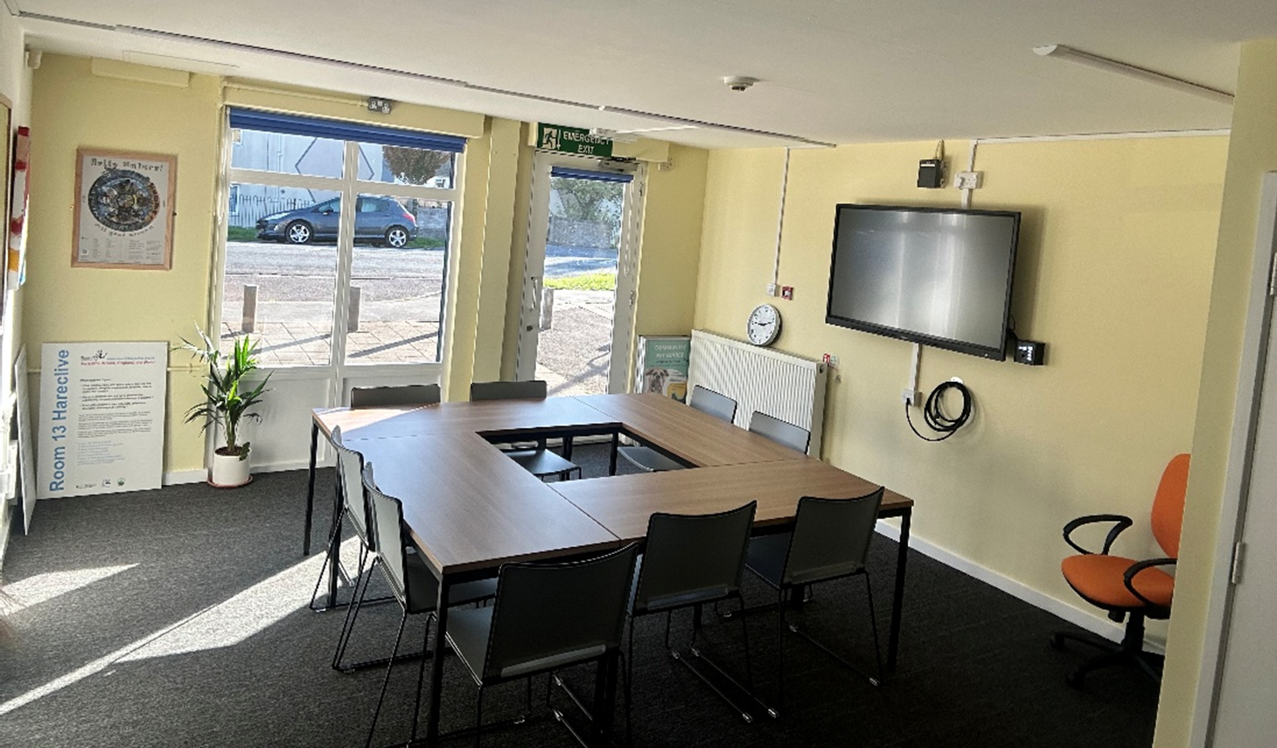
The micro-campus space at the Hartcliffe and Withywood Micro-Campus

16. Can I access materials after the course ends?
In most cases, materials will remain available for a limited time after the course finishes.
17. What happens if I miss a session?
You should inform Michelle.graffagnino@bristol.ac.uk and jane.hewer@bristol.ac.uk
🎓 Certification & Support
18. Will I get a certificate?
Yes, a certificate of completion and a transcript will be awarded if course requirements are met.
19. Who can I contact for support?
We encourage you to contact your course tutors Michelle and Jane in the first instance. We also have 6 mentors who are current University of Bristol students to provide academic and pastoral support.
20. Is there additional support if I need help?
Yes, extra support sessions or resources will be available upon request. Including use of the micro-campus space for independent study and group work projects.
🔧 Keep up to date with other events and future courses at the Hartcliffe and Withywood Micro-campus webpage.

